1. Register button on login doesn’t work

Type of error: functional error



The following error is logged in the console.

This is most probably related to an api error.

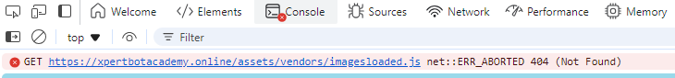

1. When clicking on the “our program” button, nothing occurs.

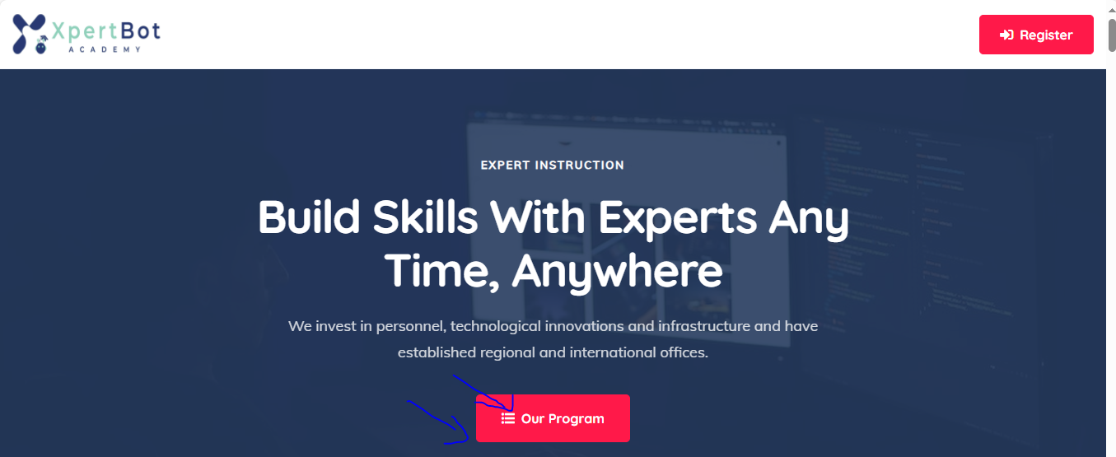

This is also a functional error because the href link is missing as shown in the element below:



1. The same error occurs in the five buttons below

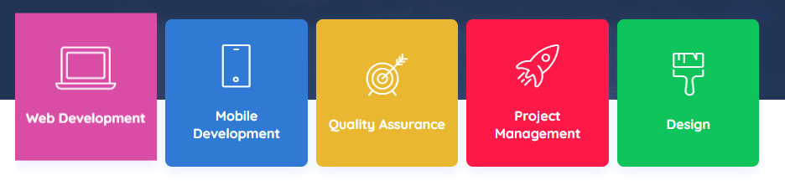

This is due to the href link being missing



1. Some of the icons in the student’s page are much larger than the others. This is a ui/ux error

This directly appears when clicking on the students link page.

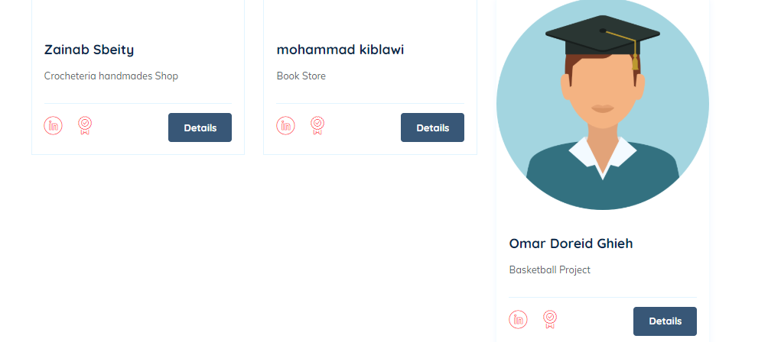

1. The join our community banner is within the contact us banner. This might be a ui/ux error

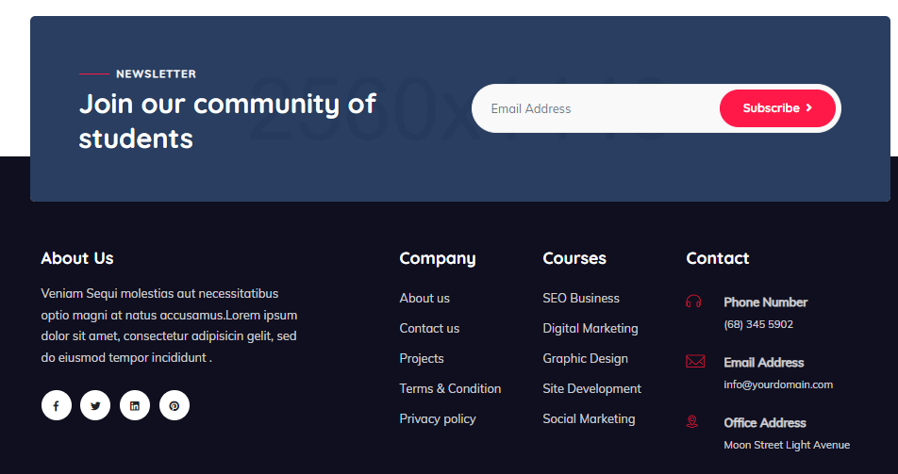

1. None of the buttons in the about us are functional. This is a functional error as all don’t have a link and just a jump up when clicked on.

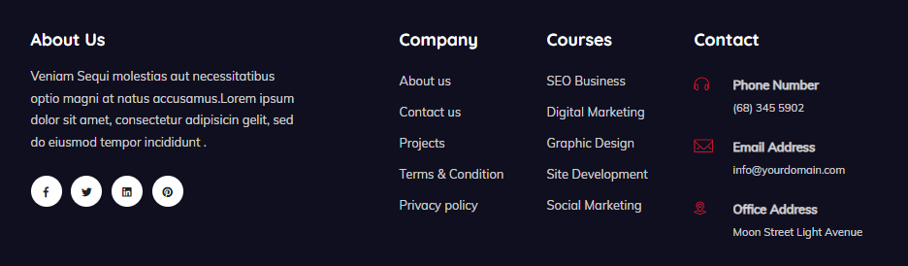

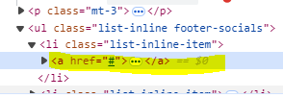

1. The learn more button in the main page doesn’t work. This is also a functional error.

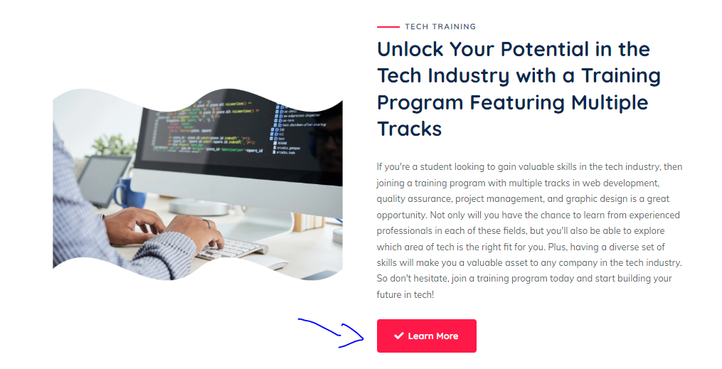



1. The height of the courses mismatch. This is a ui/ux error.







1. The watch more about us play button doesn’t work. This is a functional error

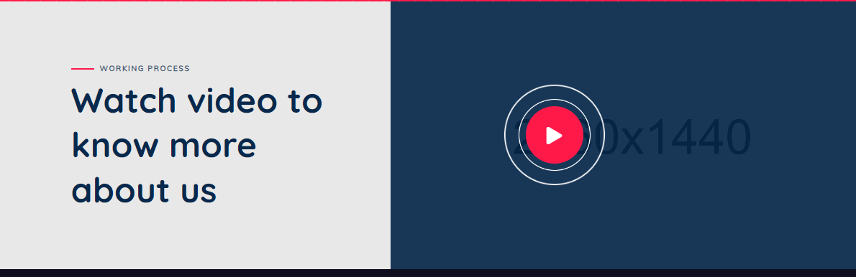

1. The courses for general, cyber security and data science are missing

